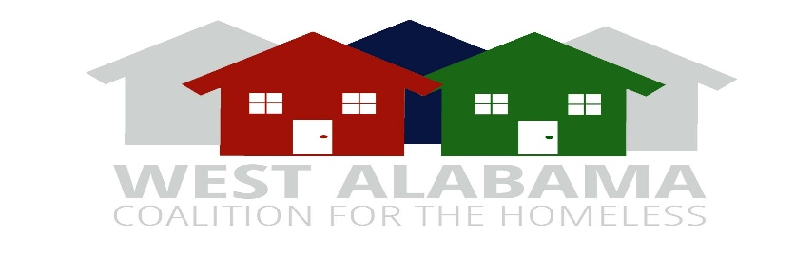
General Meeting Agenda
July 16, 2026
ZOOM
2:00 P.M.

AGENDA

- Welcome

- Review and approval of agenda

- Review and approval of April 16, 2026 Minutes

- New Business:
- None

- Unfinished Business:
- Tuscaloosa One Place representative-Dr. Karen Thompson-Jackson
- Voting on new Governance Committee Chair
- Coordinated Entry Training Updates-Vanessa Twiggs/Antwon Prince Sealy
- Strategic Plan Continuous Discussion: Mark McComas/Greg Barchuk

- Committee Reports:

- HMIS-Katara Spencer
- Community Outreach-Jashira Sullivan
- Coordinated Entry-Vanessa Twiggs
- COC Funding- Kyle Anderson
- Person with lived experiences-Rodney Williams
- Governance-Open
- Housing Resources- Antwon Prince Sealy
- Nominating and Membership-Derek Osborn
- Executive-Dr. Karen Thompson Jackson

- Announcements:
- FY 2026 CoC Builds Deadline

