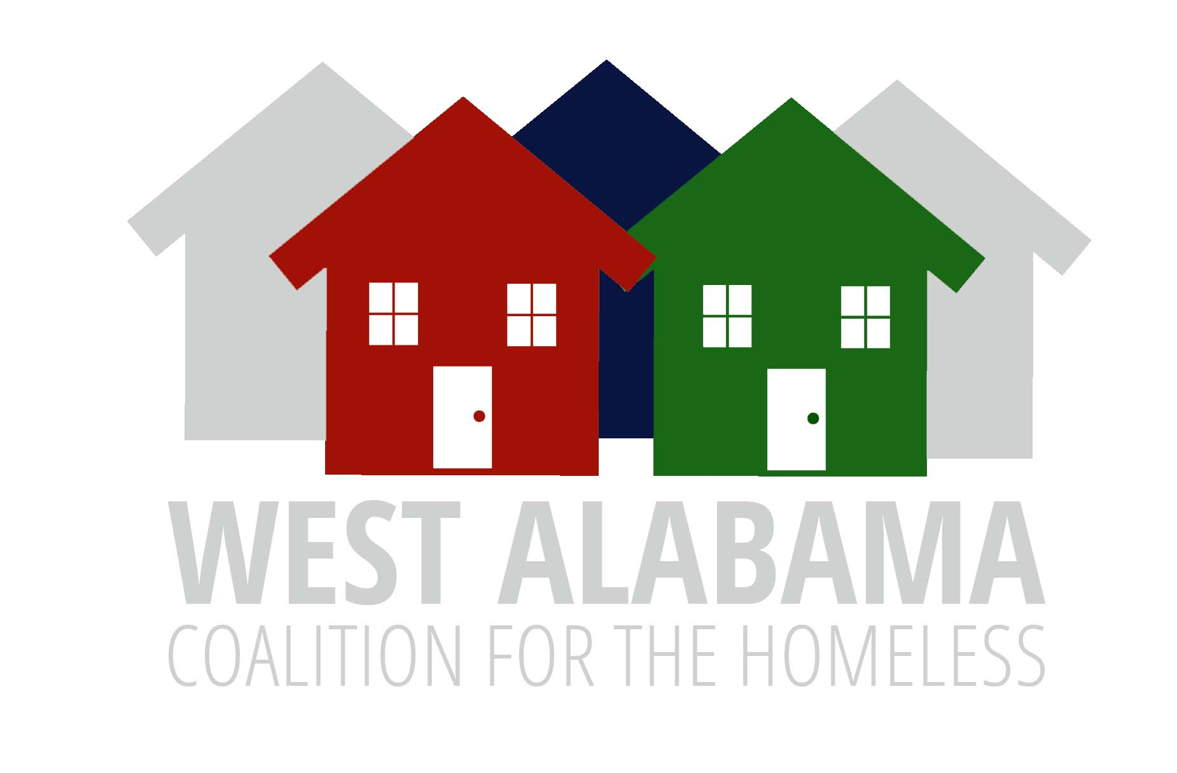

COC Meeting Minutes
July 16, 2026
ZOOM
2:00PM

Welcome
Karen Thompson-Jackson, WACH Board President, called the meeting to order with 22 on the ZOOM. A motion was made by Kim and seconded by Craig to approve the agenda as had been distributed by email. Motion carried. Susan made the motion to accept the minutes of the last meeting as distributed by email, motion was seconded and carried,

There was no new business.

Unfinished business

Tuscaloosa One Place representative-a new intake and volunteer coordinator is to be hired and will become a WACH representative. Discussion was tabled until October meeting.

Governance Committee Chair-no one has volunteered, new chair to be determined by the executive committee,

Coordinated Entry Training Update Antwon reported on the workshop training this group has participated in, looking at next steps. Goal is for all WACH to better understand Coordinated Entry and the process. Next committee meeting date to be determined. Salvation Army is considered the primary access point as it is open 24 hours a day. Other access points include First United Methodist Church, Tuscaloosa Police Department, City of Tuscaloosa, TES, Indian Rivers and Tuscaloosa One Place.

There was a discussion about a flier/ QR code that would explain the process. Also, it was asked if there is a coordinated entry tab on the website. If there are gaps, we will address and fix them.

Mark said we will continue to have conversations, there could be a different model that would better fit Tuscaloosa-for example, only having one entry point.

Karen suggested we think about how communication flows, how we can better communicate using technology, use AI prompts, etc.

Mark shared about his work with the executive committee -progress on the strategic plan and GAPS analysis. We were challenged about what we hope to accomplish as a COC. We have identified nine goals and must develop an implementation plan. It was suggested we keep things simple, short and sweet, what do we need to do to accomplish each goal?

Committee Reports

HMIS-no report

Community Outreach-the Pack a Suitcase Event was very successful-192 were assisted. The mobile showers, washers and dryers were used. This will be an annual event. The committee meets tomorrow. PIT/HIC will be discussed at that meeting. Next event is in November.

NOTE: if anyone has updates for the Resource Guide, please send them to LaKamy. 211 is also a good resource.

COC Funding-we still do not have information on funds available for new awards, The City, the Housing Authority and Community Service of West AL looking at renewal. Questions about Turning Point and First United Methodist. Neither have submitted letter of intent-has timeline been extended? It was suggested we look at the ranking tool. One Roof Birmingham has a tool we may want to look at. If interested follow up with LaKamy, Susan or Karen.

Persons with Lived Experiences-no report

Governance Committee-leadership still open

Housing Resources Committee to meet second week in August-importantly they meet, we may need to add to committee. LaKamy has a list of property managers that have shown interest, We also want to engage private owners.

Nominating and Membership-no report

Executive Committee-no report

Riverbank and Trust have expressed an interest in partnering with us, maybe sponsoring an event, etc.

Announcements

Susan reported Home Ownership classes start next Friday. If approved for a Habitat house they must attend HUD counseling classes. These are available through CSP or the City.

Kyle reported legal services is very busy but will take housing cases on an emergency basis. Also doing debt consolidation and domestic violence cases. He anticipates this will continue for 2 months or so.

Susan closed the meeting at 3:37. The next meeting is October 15 and is the annual meeting with memberships are renewed.

Kim Smith
Secretary

