LEGAL NOTICE
TAKE NOTICE THAT THE FOLLOWING PROPOSED ORDINANCE WILL BE INTRODUCED FOR PASSAGE AT THE COUNCIL MEETING OF THE OXFORD CITY COUNCIL AT ITS REGULAR MEETING ON THE 9th DAY OF June 2026, AT OXFORD CITY HALL, 145 HAMRIC DRIVE EAST, BEGINNING AT 6:30 P.M. AT THE ABOVE TIME AND PLACE. ALL PERSONS IN OPPOSITION TO SAID PROPOSED ORDINANCE AND ALL PERSONS IN FAVOR OF SAID ORDINANCE WILL HAVE AN OPPORTUNITY TO BE HEARD AS TO THEIR POSITION PRIOR TO THE INTRODUCTION OF SAID PROPOSED ORDINANCE FOR PASSAGE BEFORE THE COUNCIL.
PROPOSED ORDINANCE NUMBER 2026-

AN ORDINANCE AMENDING THE ZONING ORDINANCE OF THE CITY OF OXFORD, ARTICLE 8, PARKING, SECTION 8.02, REQUIRED OFF-STREET PARKING SPACES, (ORDINANCE NO. 2017-20, 9/26/2017)

BE IT ORDAINED by the City Council of the City of Oxford, Alabama, as follows:

SECTION 1. Upon recommendation of the Planning Board of the City of Oxford the Council hereby amends Article 8, Parking, Section 8.02, Required Off-Street Parking Spaces, of the above referenced Ordinance so that it shall read in its entirety as follows:

Section 8.02 Required Off-street Parking Spaces

Unless otherwise provided for, all uses must conform to the minimum parking space requirements outlined in Table 8-1. In situations where the required number of parking spaces is not readily determinable by Table 8-1, the Zoning Official is authorized to determine the parking space requirements using the table as a guide.

Shared and joint parking.

Subject to approval by the Commission, minimum parking requirements for a mixed-use development may be reduced by calculation of shared parking requirements for the development using the shared parking demand information in Table 8-2.

A joint parking area may contain required parking spaces for more than one use, provided the combined number of spaces complies with the parking for all uses. If, however, the combined uses wish to make use of the same spaces at different times, the same spaces may be credited to each separate use. The applicant for a, combined use facility must present documentation of a combined parking agreement; and, if sharing the same spaces, a time schedule for allocation of such spaces.

Table 8-1 Required Off-Street Parking Spaces by Use
Agricultural Uses
Farm | 1 per 1.05 employees
Farm Stand | 1 per 250 sf of retail floor area
Farm Support Business | 1 per 1.05 employees, plus 1 per company vehicle
Stable | 1 per 3 persons of occupancy load plus 1 per 1.05 employees
Residential Uses
Accessory Dwelling | 1 per DU
Boarding House | 1 per BR
Duplex | 2 per DU
Independent Living Facility | 2 per 3 DUs plus 1 space per employee
Manufactured Home | 2 per manufactured home lot (in manufactured home subdivision)
Multifamily Developments | 1 per studio, efficiency or 1-BR unit  1.75 per 2-BR unit  2.0 per 3+ BR unit
Single-family Dwellings  Attached  Detached (except GH)  Garden homes (GH) | 2 per DU plus 1 additional space per 3 DUs  2 per DU  2 per DU plus 1 additional space per 3 DUs
Institutional Uses
Assisted Living Facility | 1 per 4 residents plus 1 per employee
Club | 1 per 100 sf of non-storage and non-service floor area
Community Center | 1 per 300 sf of GLA
Country Club | 1 per 3 persons of occupancy load
Day Care Center | 1 per employee, plus 1 stacking or parking space per 8 persons enrolled of occupancy load
Group Care Home | 1 per 4 beds plus 1 per employee
Hospital | 1 per 2 patient beds plus 1 per emergency room bed plus 1 per employee
Library | 1 per 500 sf of GLA
Nursing Care Facility | 1 per 4 beds plus 1 per employee
Place of Assembly | 1 per 3 seats in the main assembly space
Public Facility | 1 per 300 sf of GLA
Rehabilitation Facility | 1 per 4 beds plus 1 per employee
School, College or University | 1 per 5 students plus 2 per 3 employees
School, Elementary or Junior High/Middle | 1 per classroom, plus either 1 per employee or 1 per 3 seats in the main assembly space (whichever is greater)
School, High | 1 per 8 students of occupancy load, plus either 2 spaces per classroom or 1 per 3 seats in the main assembly space (whichever is greater)
School, Vocational | 1 per 3 students of occupancy load plus 1 per employee
Commercial Uses
Animal Hospital | 1 per 300 sf of GLA
Appliance Store | 1 per 400 sf of GLA
Art Gallery | 1 per 350 sf of GLA
Automobile Dealership | 1 per 200 sf of interior sales area plus 1 per 4,000 sf of outdoor display area plus 1 stacking space per service bay
Automobile Parts Store | 1 per 400 sf of GLA plus 1 per employee
Automobile Rental Establishment | 1 per 400 sf of GLA plus 1 per rental vehicle
Automobile Repair Service | 1 per employee plus 2 stacking spaces per service bay plus 1 per company vehicle
Bank (no drive-thru) | 1 per 250 sf of GLA
Bank (drive-thru only) | 1 per 2 employees plus 3 stacking spaces per teller
Bank (with drive-thru) | 1 per 350 sf GLA plus 3 stacking spaces per teller
Barber or Beauty Shop | 2.5 per chair
Bed and Breakfast | 1 per guest bedroom plus 2 spaces
Bowling Alley | 3.5 per bowling lane
Call Center, Telemarketing Office | 1 per 150 sf of GLA or 1 per employee, whichever is greater
Car Wash (full service or automated) | 1 per employee plus 4 stacking spaces per bay
Car Wash (self-service) | 3 stacking spaces per approach lane plus 2 drying spaces per stall
Clinic | 6 per practitioner
Commercial School | 1 per 3 students of occupancy load plus 1 per employee
Convenience Store | 1 per 200 sf of GLA
Dry Cleaning Pick-Up | 1 per 300 sf of GLA
Funeral Home | 1 per 1 employee plus 1 per 3 seats of occupancy load plus 1 per company vehicle
Furniture Store | 1 per 600 sf of GLA
Service Station | 2 per service bay plus 1 per company vehicle plus 1 per employee plus 1 stacking space per fuel island
Gas Station/ Convenience Store | 1 per 300 sf of GLA plus 1 stacking space per fuel island
General Retail Business | Under 50,000 sf: 1 per 200 sf of GLA  50,000-99,999 sf: 1 per 250 sf of GLA  100,000+ sf: 1 per 300 sf of GLA
Home Improvement Center | 1 per 400 sf of GLA
Hotel or Motel | 1 per room plus 1 per employee
Laundromat | 1 per 2 washing machines
Liquor Lounge (free standing) | 1 per 100 sf of GLA
Mini-warehouse | 5 spaces adjacent to leasing office (if any)
Office, business or professional | 1 per 400 sf of GLA
Movie Theater | 1 per 3 seats
Outdoor Recreation  Golf Course:  Miniature Golf:  Golf Driving Range:  Other: | 4 per hole  2 per tee  1 per tee  1 per 3 persons of occupancy load
Pool Hall | 1 per table
Restaurant, Take-out or delivery only | 1 per employee plus 1 per 300 sf of GLA
Restaurant, Drive-in | 1 per ordering station plus 1 per employee
Restaurant, Drive-thru | 1 per 100 sf of GLA plus 4 stacking spaces per drive-thru window
Restaurant, Standard | 1 per 3 seats of occupancy load
Shopping Center | see General Retail, plus requirements for other uses
Unenclosed Retail | 1 per 500 sf of display area plus 1 per employee
Industrial Uses
General Industry and Manufacturing, Research Laboratory and similar uses | 1 per 1 employee plus 1 per company vehicle but not less than 1 per 1,000 sf of GLA
Warehouse, distribution and wholesale Business | 1 per 1 employee plus 1 per company vehicle but not less than 1 per 500 sf of GLA

Location of Required Parking. All required parking spaces must be located on the same lot as the use served by the parking, except as provided below:

Required parking within planned residential developments may be provided in common parking areas.

If the number of required parking spaces cannot reasonably be provided on the same lot or premises as the served use, remote parking may be permitted by a Special Exception if within 400 feet of the concerned lot(s). Such Special Exception requires written legal documentation that the user of such remote spaces has the right to such spaces.

Parking Restrictions

The use of off-street parking in any residential district for nonresidential purposes may only be permitted upon approval of a Special Exception by the Board of Adjustment.

The use of any required parking space for the storage of any motor vehicle for sale or for any purpose other than parking is prohibited.
- Any commercially zoned property wishing to have a gravel parking lot must meet City standards and be approved by the City Engineer.

Table 8-2: Typical Shared Parking Demand by Use and Time of Day*
Parking Demand by Use | Weekday  8am-5pm | Weekday  6pm-12am | Weekday  12am-6am | Weekend  8am-5pm | Weekend  6pm-12am | Weekend  12am-6am
Residential | 60% | 100% | 100% | 80% | 100% | 100%
Office | 100% | 20% | 5% | 5% | 5% | 5%
Commercial | 90% | 80% | 5% | 100% | 70% | 5%
Lodging | 70% | 100% | 100% | 70% | 100% | 100%
Restaurant | 70% | 100% | 10% | 70% | 100% | 20%
Entertainment | 40% | 100% | 10% | 80% | 100% | 50%
Movie Theater | 40% | 80% | 10% | 80% | 100% | 10%
Institutional (non-church) | 100% | 20% | 5% | 10% | 10% | 5%
Institutional (church) | 10% | 5% | 5% | 100% | 50% | 5%
* Different parking demands may be used than the typical shown if documented in a parking demand study.

Design Requirements

The minimum parking space dimensions are as shown in Table 8-3.

In parking areas of 20 or more parking spaces, up to 20% of the spaces may be reserved for compact cars. Such spaces must contain a minimum rectangular area of eight ft width and 16 ft length. These spaces must be conspicuously marked for compact cars only.

Stacking space must contain a minimum rectangular area of 10 ft in width and 20 ft in length and be separate from parking aisles and spaces.

Handicapped parking spaces must be provided and designed in accordance with the applicable provisions of the Americans with Disabilities Act.

Parking areas must be designed so that vehicles may exit such areas without backing onto a public street. This requirement does not apply to parking areas that serve single-family or duplex lots; although, backing into arterials is prohibited in all cases.

The location and design of off-street parking areas may not cause the destruction of any public right-of-way or easement, sidewalks, or trees located on any public right-of-way except as approved by the City for installation of driveways.

Table 8-3: Parking Lot Dimensional Requirements
Parking Angle | Stall Width (A) | Stall Length (B) | Stall Depth (C) | Curb Length (D) | Aisle Width (E) |  | Interlock (F)
 |  |  |  |  | One-Way | Two-Way | Interlock (F)
0° | 8 ft | 22 ft | 8 ft | 22 ft | 12 ft | 20 ft | na
30° | 8.5 ft | 20 ft | 17.4 ft | 17 ft | 15 ft | 20 ft | 3.9 ft
45° | 8.5 ft | 20 ft | 20.2 ft | 12 ft | 15 ft | 20 ft | 3.2 ft
60° | 9 ft | 19 ft | 21 ft | 10.4 ft | 20 ft | 24 ft | 2.3 ft
90° | 9 ft | 19 ft | 19 ft | 9 ft | 20 ft | 24 ft | na

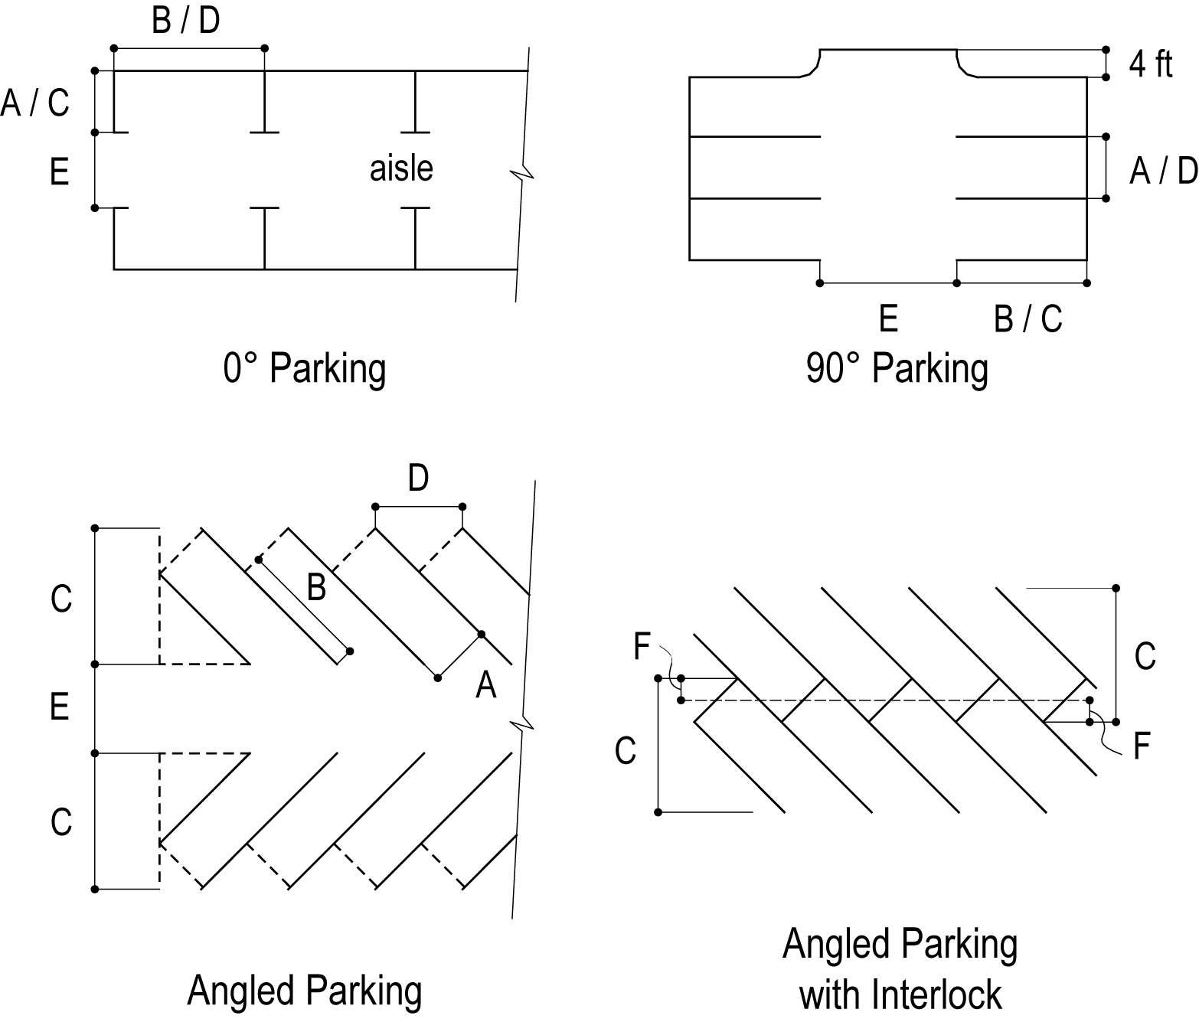

Parking areas for all developments must be so designed that sanitation, emergency and other public service vehicles can adequately and safely serve such developments without the necessity of backing unreasonable distances or making other dangerous maneuvers. Fire lanes may be required by the Fire Code.

All parking areas must be surfaced with dust-free materials resistant to erosion and maintained in good condition, i.e. free of pot holes, weeds, trash, refuse, etc.

Parking spaces, except those serving single-family or duplex dwelling units, must be demarcated with painted lines or other markings.

Driveways serving more than two parking spaces must provide adequate turn-around space on the lot.

Drainage in parking areas must direct storm water back into the site toward adequate drainage channels. Parking areas of 20 or more spaces may be required to provide on-site storm water detention to mitigate the sudden discharge of high volumes of storm water into the public drainage system. Drainage plans are subject to approval by the City Engineer.

Section 2. This Ordinance shall become effective upon passage by the Council and by advertising as required by law.
APPROVED and ADOPTED this ____ day of _____________, 2026.
CITY COUNCIL OF THE CITY OF OXFORD, ALABAMA
Chris Spurlin, Council President; Phil Gardner, Charlotte Hubbard, Mike Henderson, Steven Waits, Councilmembers
Approved Alton Craft, Mayor; Attest: Alan B. Atkinson, City Clerk
Dated this 15th day of May, 2026.

The City of Oxford, Alabama, Alan Atkinson, City Clerk.

