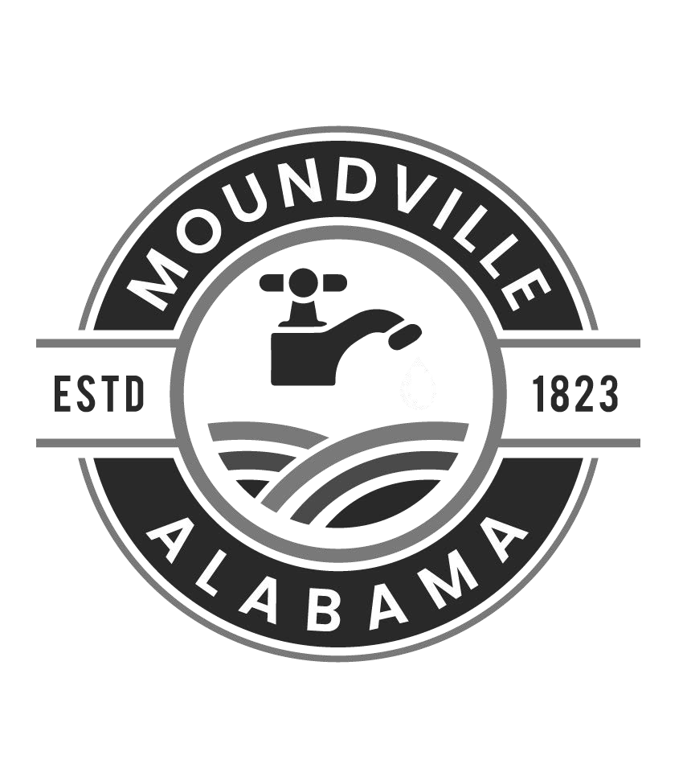

City of Moundville

Water Works and Sewer Department

REQUEST TO DISCONNECT

Please complete all information below, the print and sign the document. You may Fax, Drop off, or mail Disconnect request to Moundville City Hall (address is listed below).

Customer Name (as it is shown on account):
Account Number:

Current Service Address:

Requested Cancellation Date:

Name of Person Submitting Request: Contact Phone Number:

Forwarding Address (required to process request)*:

*PLEASE NOTE: If you wish to receive full amount of deposit back, the account must be up to date on payment by or before water services are disconnected. If account is not up to date on payment the City will deduct that amount from refund and mail you the remainder. I am aware that $50.00 Reconnection Fee and a $300.00 meter deposit must be paid before service will be turned back on.

Customer Sign Date__________

Water Clerk Sign

The City of Moundville is an equal employment and non-employment opportunity employer.
410 Market Street Moundville, AL 35474
P.O. Box 98 Moundville, AL 35474
Phone: (205)371-2641 Fax: (205)371-9160

