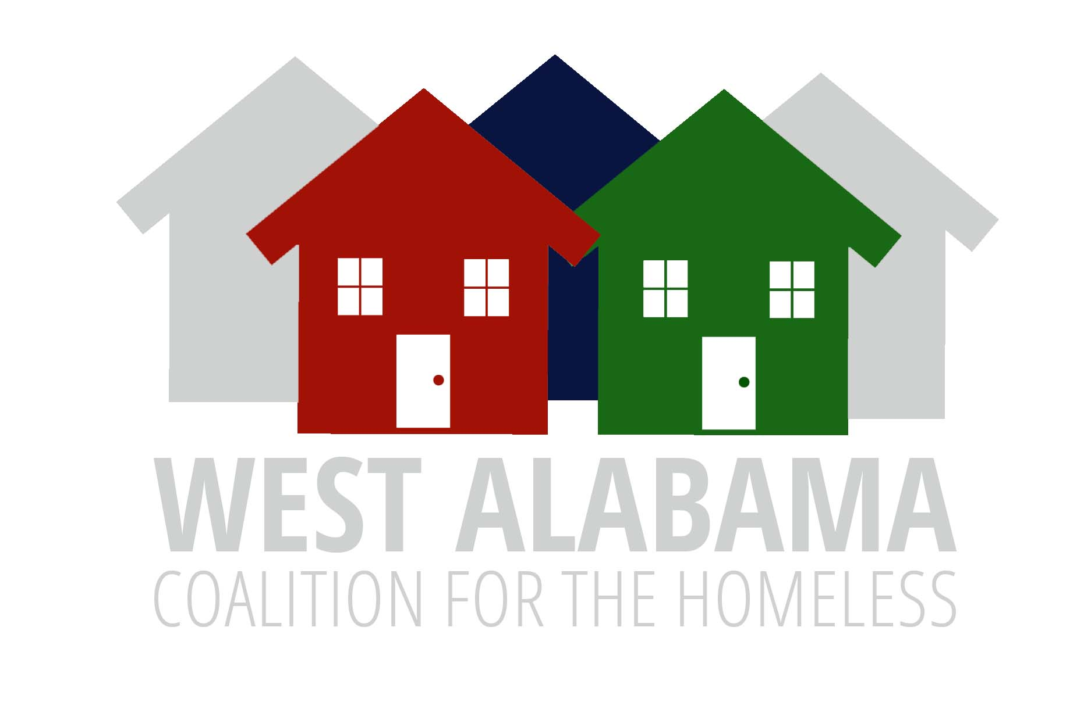

COC Board Meeting Agenda
July 10, 2025
Zoom
11:30AM

Welcome

Review and approval of November 2024 Minutes

New Business
None

Unfinished Business
  - Review and Discussion of the Gaps Analysis

Announcements

