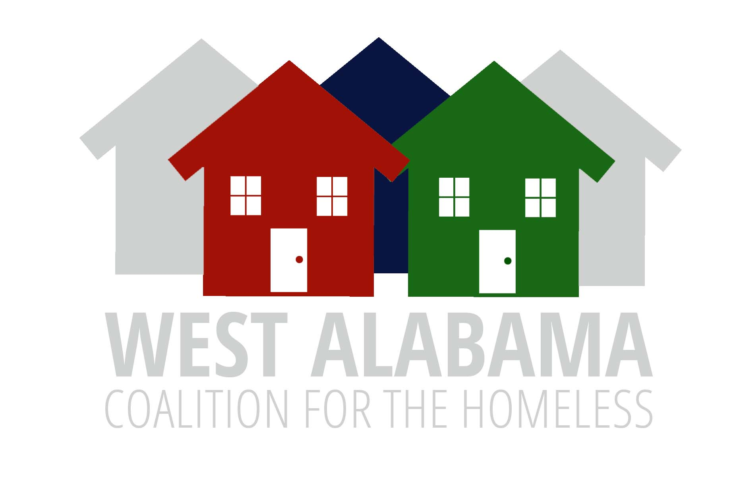
Board/ COC Meeting Minutes
July 10, 2025
Via Zoom
11:30 AM

Welcome
Karen Thompson-Jackson, WACH Board President, called the meeting to order at 11:40AM. Fifteen people were in attendance.

- Reviewed and approved the agenda as was distributed by email. Also, reviewed and approved the November 2024 meeting minutes as distributed.

- New business: None

- Unfinished business-
GAPS analysis-Heather Hill led the discussion. She explained we need to focus on the last 2-3 pages especially the recommendations. We need to provide feedback to ICF (HUD) and move to the three-year strategic plan. We must determine if the recommendations are relevant, the problem has grown, etc.

Gaps Analysis Sections to discuss:
- #1 Establish Targeted Communication Strategies. Can we do more community engagement? We need to go to groups, not expect them to come to us. Outreach Committee? Maybe marketing and getting buy in from COC should be mutually beneficial. Not all invited to the table understood the full capacity of what we offer. We need to get on the agenda with the Board of Realtors, Alabama Baptist, Zoning Board, City Council, etc. We need more formal processes.

- #3 Develop a Central Navigation Hub. Outreach? Marketing? Mentions Community Wide System, Coordinated Entry may could broaden. Do they know we have Case Connect? Are we doing a good job? Do we have adequate funding to do these things. Are these aspirations, challenges. Opportunities???Are there things we can do to make services operate better? Are there funds?

- #5-Maxamize Use of Existing Housing Units. What do they mean by COC funded units? Vouchers? Do they think we have fixed housing? This needs to be clarified.

- #7 Reassess and Reallocate City Funding. City funding is only used within the city limits; we serve a larger area. Speaks to sanitation-do they mean hygiene? Portable showers, washers and dryers, etc. We need the county at the table. Faith based groups need better representation. Is this a recommendation WACH can do? Can we revise the language-advocate for…, present strategy for…, promote, facilitate conversations, etc.

- Announcements
There is a new regional coordinator for COC. They are offering seminars/workshops. September 1-November 17. Things like understanding the Coordinated Entry System, HMIS, and Understanding and Securing Buy in. The invitation will be sent out after this meeting. The deadline for registering is July 28.
- Next Board meeting November 6, 2025
Anderson made a motion to adjourn, and Ingrid seconded. Meeting closed at 12:40 p.m.

