That You May Be Children
A Meditation on Matthew 5: 38 – 48
Rev. Cathy C. Hoop Grace Presbyterian Church February 23, 2020

But I say to you, love your enemies and pray for those who harass you so that you will be acting as children of your Father who is in heaven. Matthew 44-45 (CEB)

Loving those who don’t love you. Praying for those who may only pray curses upon you. Turning the other cheek, giving your coat away. Walking the extra mile. These aren’t the actions of the weak. They are the choices of the strong. And wrapped up in all of these complex practices is the question of forgiveness.

Forgiveness is so tricky. We love it when we are on the receiving end of it. Depending upon the situation, we don’t love it so much when others are on the receiving end. Nor do we necessarily love it when we are the ones expected to offer it. Forgiveness is love embodied, love enfleshed.

We have a complicated relationship with forgiveness.

Can we even say we always love it when we are on the receiving end? To accept forgiveness is to own up to what we have done wrong. To name it and claim it, to acknowledge our humanity. We don’t love that.

We have a complicated relationship with forgiveness.

We ask for forgiveness, but we either don’t think we deserve it or don’t really think we need it. We ask for forgiveness. We offer forgiveness. We even say the words, “I forgive you,” but do we live forgiveness? Do we say we forgive but hold that grudge deep inside?

“I’m sorry I used most of the yellow crayon.” That’s a note I found under my office door one day after church – or it was handed to me. I don’t quite remember. I’ve kept it. It is frame worthy. I have no idea what prompted this response. But Emma, during worship one day, clearly needed a lot of yellow crayon. To draw kittens? Or sunshine? Or kittens in sunshine? Or yellow flowers? Or kittens in the sunshine with yellow flowers?? Or maybe just a basket of bananas? I have no idea. But for some reason, Emma felt regret for using so much of the yellow crayon. She was concerned that someone should know about this situation, so that more yellow crayons could be found, so that other children could come back the next Sunday and draw all the yellow things that needed to be drawn.

To live with that level of compassion and empathy? To live with that level of concern and awareness? What a Jesus’ dream-come-true world this would be. But most of the time we don’t know how to love like that. We “sort of/kind of” know how to love the people near us. On most days we manage that. But the people we don’t have to see? The stories we don’t have to hear?

This past Thursday, Tennessee executed Nicholas Todd Sutton, a man who was responsible for murdering three people when he was 18, crimes for which he received life sentences. He killed another man while in prison, for which he received the death penalty. Seven current and former prison officials advocated for clemency. They just wanted his sentence reduced to life in prison. The victims’ families protested his execution. Sutton, during his 35 years in prison, had intervened during prison riots, saving the life of at least one guard, and defending others. He had somehow managed to befriend both the guards and the inmates which must have required both personality and skill. He had become a counselor to his companions on death row, and the guards praised him for making the prison safer for everyone. The guards needed him alive.

The facts that were not allowed during his defense trial are these: as an infant, he was abandoned by his mother. His father, addicted to drugs and alcohol, neglected and abused him. One day he showed up for school with a broken arm, a wound inflicted by his father. By age 12, Sutton was encouraged to drink alcohol and take drugs with his father. None of this justifies or negates Sutton’s crimes. But the truth is that the system failed to protect him when he was just a child, failed to rescue him when he was a child, and then the system took his life. Though he had changed his life, though he was doing whatever he could to bring light into his corner of the world, the state of Tennessee killed him. Because he was an enemy.

We have a complicated relationship with love, and with love’s partner, forgiveness. We prefer quick solutions. We prefer revenge. We say that execution of a criminal brings closure, but we know that’s not true. If you have suffered a grief, a trauma, you know there is no “closure.” The wound may be knitted back together, but the scar remains. The loss remains.

Sutton was executed the same week that we witnessed our President pardoning, among other convicted criminals, former Illinois governor Rod Blagojevich, saying that he “seems like a very nice person” and financier Michael Milken. Have either of them shown remorse for their abuses? Is it once again about who you know and how much money you have? We can show love to when we can relate to their faults? When we walk in the same circles? When their crimes are only “white collar” crimes? After all, even Jesus hung out with tax collectors.

We have a complicated relationship with love, with forgiveness. And a strange method for deciding which enemies to love and which ones to hate. Yes, Jesus did hang out with tax collectors, but he hung out with all kinds of people from all walks of life. He called all people to repentance. All people: his disciples, his family, his friends, the religious leaders, the political leaders. All people.

On the same night that Sutton was executed, I was sitting in a Moms Demand Action meeting, listening to a young mother describe how she has frequently needed to force her children to the floor and shield them with her body because of the gunshots outsider her window. At her home - here in Tuscaloosa. Her story was followed by a powerful statement from Rev. Dr. Tyshawn Gardner, pastor of Plum Grove Baptist Church, who reminded us that we must name and address the roots of racism in our country, roots of oppression that have led to the epidemic of despair within so many black communities. Because black people were seen as enemies by whites. Defined as less than.

Dovetailing so powerfully with Gardner’s speech, our own Dr. Erik Peterson offered a lecture at Theater Tuscaloosa, in which he uncovered the racist propaganda which propelled a campaign to denounce the teaching of evolution. “Don’t waste your money on “23 and Me,” (ancestry site) Erik said. “I can tell you we are all African.” And that was the truth that so many whites frantically worked to cover up, as highlighted by the Scopes trial.

And so we call our own family our enemies, and cause excruciating pain through our abuses of power, through the perpetuation of racism and hate. We have a complicated relationship with love and forgiveness.

The first weekend of February I shared with you that I had the privilege of hearing Elizabeth Ann Eckford, one of the Little Rock Nine, share her story of what happened that day when she showed up for classes at the formerly all-white Central High School. She shared of the traumatic events of that day, and of the photograph that is seared in our nation’s memory. Eckford also told us that she and Hazel Bryan Massey became friends for a time. Massey deeply regretted her behavior on that day, and when a photographer asked them to meet again, 40 years later, she was eager to do so. But their friendship could not be sustained. Eckford said that Massey’s expectations were unrealistic, and has been quoted as saying, “True reconciliation can occur only when we honestly acknowledge our painful, but shared past.” (https://www.history.com/news/the-story-behind-the-famous-little-rock-nine-scream-image) Eckford could forgive, but she could not set Massey free from the pain she had inflicted; she could not pretend that her life had not been permanently disfigured. Yet time and time again she has revisited that painful day so that, perhaps, we can learn to live together more peacefully. She has reopened that wound in hope that others will not have to be wounded. Her story has the potential to transform enemies into friends. But it comes with a personal price.

As it did for Jesus.
Eckford’s story reminds us that we can find ways to love our enemies even if we haven’t made it all the way to forgiving them, even if we never anticipate being able to forgive them. Love requires that we enact our forgiveness, embody it, so that hate will not have room in our lives.

February is almost past. On Wednesday we will enter the journey into Lent, a season in which we are asked to examine our hearts, its deepest corners.
God pours forgiveness upon us, that we may have the ability to love even our enemies. But being forgiven by others is not something we can demand, even as we seek to live out our repentance.

May God guide us to be so sensitive, so compassionate, that we even care to acknowledge the simplest things, even the using up of the yellow crayons. Thanks be to God. Amen.

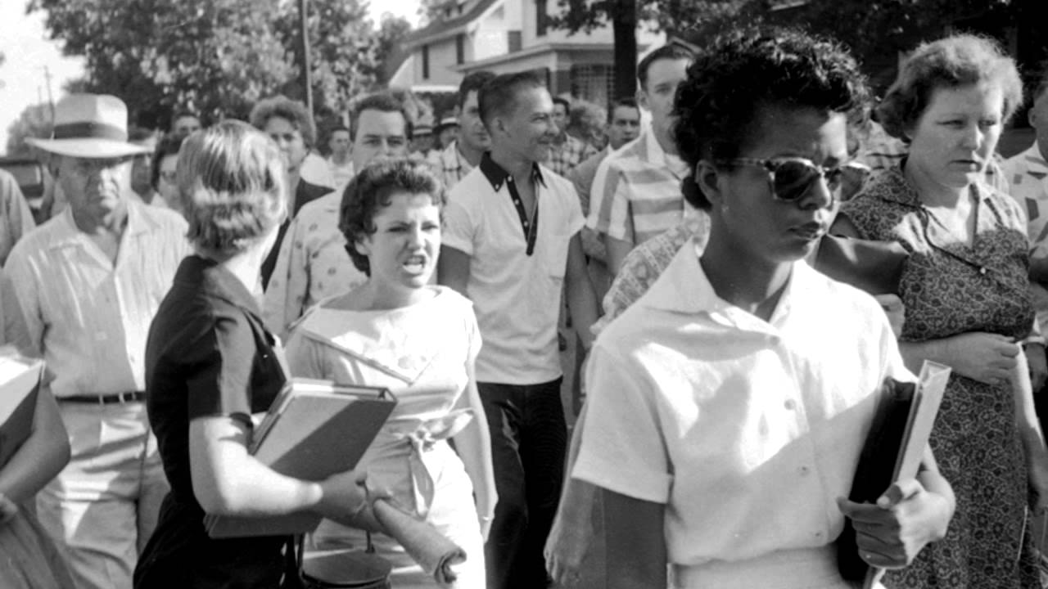
September 4, 1957. Photo by Will Counts

